DATA VISUALIZATION AND
REPORTING IN LOGISTICS
Delivery Logistics Performance Analysis

Week 2 Assignment
Tool: Microsoft Power BI
Dataset: Delivery Logistics Cleaned Dataset

Prepared by: Anshika
Date: 27 September 2026

1. Introduction
Logistics operations generate large volumes of information related to deliveries, routes, vehicles, delivery partners, costs, customer ratings, weather and delivery status. The purpose of this assignment is to transform that operational data into clear visual information that can support monitoring and decision-making.
A Power BI report was developed using a cleaned delivery logistics dataset. The report focuses on shipment volume, delivery time, cost, ratings, delays and operational patterns across regions, weather conditions, delivery partners, vehicles, package types and delivery modes.

2. Objectives
- Convert logistics data into clear and decision-oriented visualizations.
- Identify patterns in delivery delays, delivery time and delivery cost.
- Compare logistics performance across regions, delivery partners, vehicles and delivery modes.
- Present key operational metrics through an easy-to-read dashboard.
- Demonstrate how visual communication can support logistics planning and performance monitoring.

3. Dataset Overview
The analysis uses a cleaned delivery logistics dataset containing approximately 25K delivery records (the Power BI count card displays 25.00K records). The dataset contains operational and performance fields used to construct the report.
Field / Metric | Purpose in Analysis
Delivery ID | Counts the number of deliveries.
Delivery Partner | Compares partner-level delay and rating patterns.
Delivery Mode | Compares delivery volume, status and cost.
Region | Compares regional delivery performance.
Weather Condition | Examines delay counts under different weather conditions.
Vehicle Type | Analyzes vehicle-level delays and delivery time.
Package Type | Shows the distribution of deliveries by package category.
Distance / Distance Category | Examines distance-related delivery performance.
Delivery Time / Expected Time | Supports time and delay analysis.
Delivery Cost | Supports cost comparison.
Delivery Rating | Provides a service-quality indicator.
Delivery Status / Delayed | Shows operational outcomes and delay patterns.

4. Tools Used
Microsoft Power BI Desktop was used to import the cleaned CSV dataset, create visuals, arrange dashboard pages and analyze logistics performance.

5. Visualization and Dashboard Design
The report is organized into three pages so that high-level KPIs, detailed comparisons and operational breakdowns can be viewed separately. Cards are used for headline KPIs, column charts for category comparisons, scatter plots for relationships between numerical variables, and a donut chart for delivery-status composition.
- KPI cards: Total Deliveries, Average Delivery Time, Average Delivery Rating and Average Delivery Cost.
- Clustered column charts: used to compare regions, weather conditions, partners, vehicles, package types and delivery modes.
- Stacked column chart: used to compare delivery status across delivery modes.
- Scatter plots: used to inspect relationships between distance and delivery time/cost.
- Donut chart: used to communicate the proportion of delivered, delayed and failed shipments.
- A consistent blue visual theme and white dashboard background were retained for readability.
- The dashboard uses grouped layouts to make comparisons easier and reduce visual clutter.

6. Dashboard Page 1 — Logistics Overview
The first page provides an executive-level view of logistics performance. It begins with four KPI cards and then moves to category-level delay analysis and the relationship between distance and delivery time.
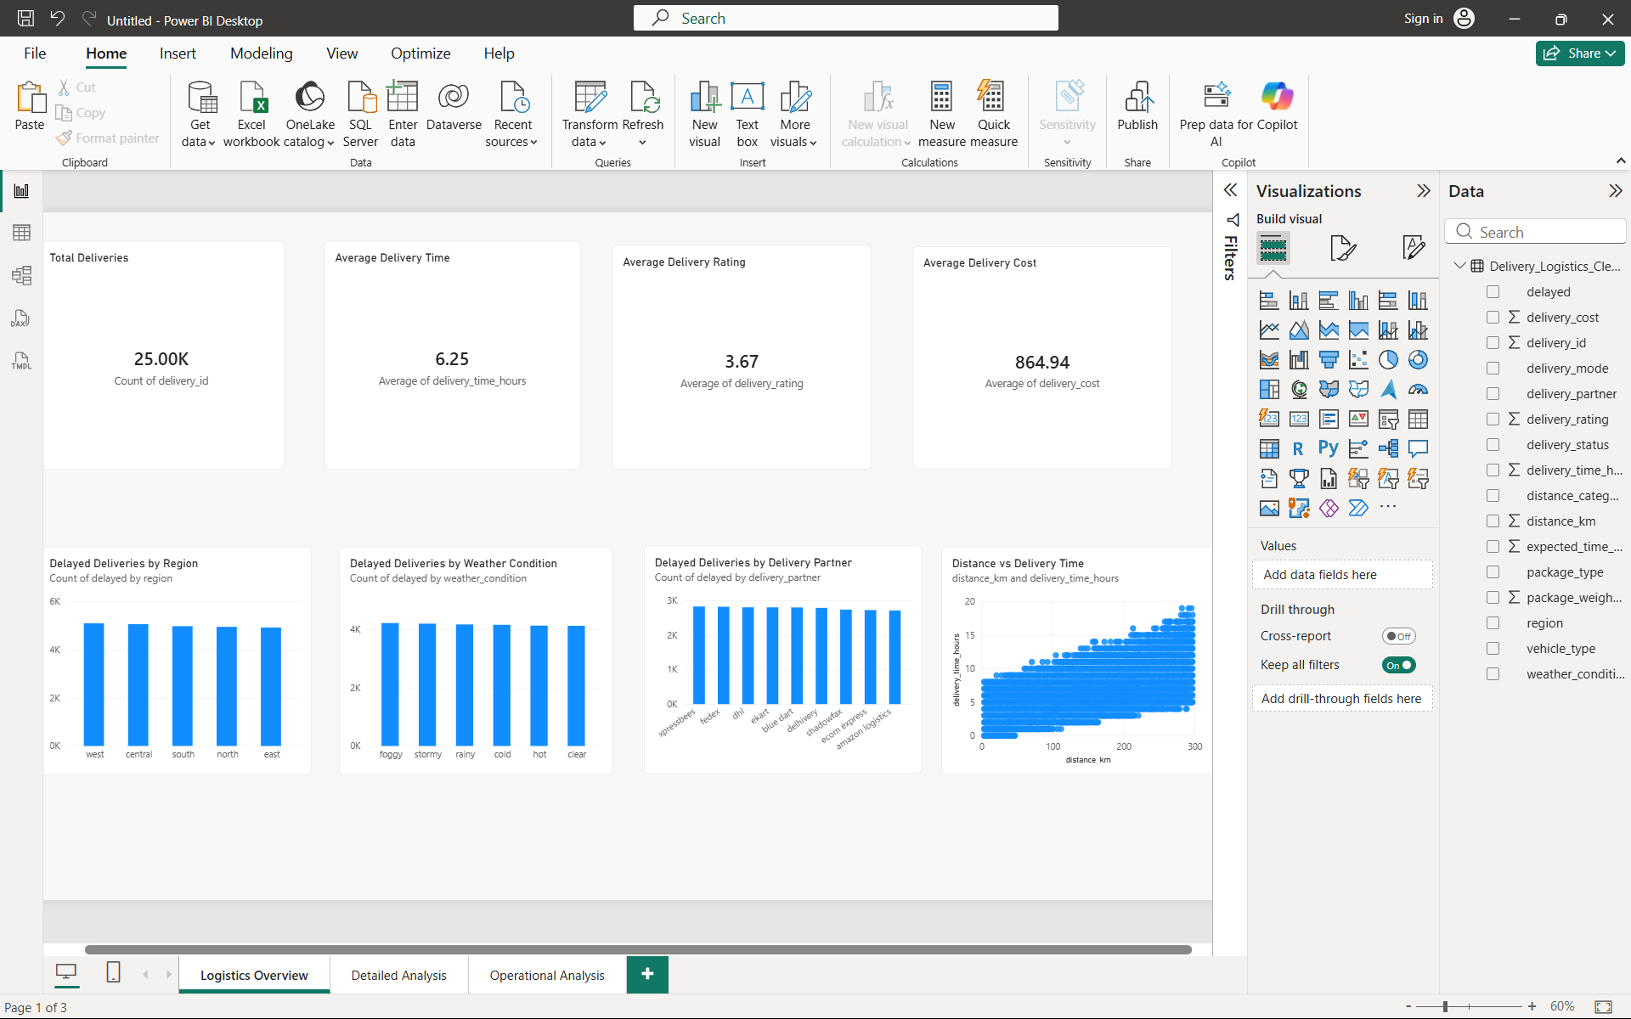
Figure 1. Logistics Overview dashboard.

Visualization rationale and observations
KPI Cards: Cards provide an immediate summary of the main operational indicators. The report shows approximately 25K deliveries, average delivery time of 6.25 hours, average rating of 3.67 and average delivery cost of 864.94.
Delayed Deliveries by Region: A clustered column chart makes regional comparison straightforward. The bars are relatively close in height, indicating that delay counts are broadly similar across the five regions rather than being concentrated in one region.
Delayed Deliveries by Weather Condition: The chart compares delay counts across foggy, stormy, rainy, cold, hot and clear conditions. The values are visually close, so the dashboard does not show a large difference in delay volume among the displayed weather categories.
Delayed Deliveries by Delivery Partner: A partner comparison allows operations teams to identify differences in delay volume. The displayed bars are relatively similar, suggesting broadly comparable delay counts among the listed partners.
Distance vs Delivery Time: A scatter plot is appropriate because both variables are numerical. The points show an upward relationship: deliveries at greater distances generally have higher delivery times. This supports the use of distance as an important factor when planning delivery-time expectations.

7. Dashboard Page 2 — Detailed Analysis
The second page focuses on relationships between delivery mode, status, region, cost, ratings and vehicle type. It provides more detailed comparisons that can support operational diagnosis.
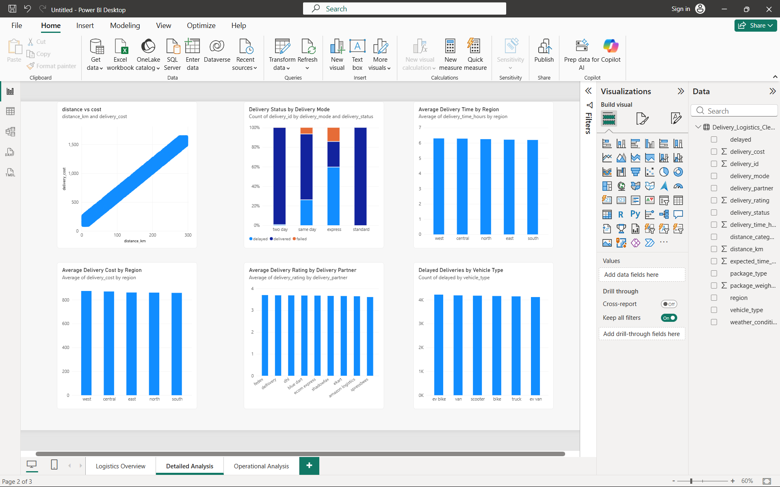
Figure 2. Detailed Analysis dashboard.
Distance vs Delivery Cost: The scatter plot shows a strong upward pattern between distance and delivery cost. Longer-distance deliveries generally have higher costs, which is useful for route and pricing analysis.
Delivery Status by Delivery Mode: A stacked column chart shows the composition of delivered, delayed and failed shipments for each delivery mode. The visual makes differences in status mix between modes easier to identify.
Average Delivery Time by Region: Regional average delivery times are close to one another, around the 6-hour range. This suggests that average time performance is relatively consistent across the regions represented.
Average Delivery Cost by Region: Regional average costs are also fairly close, roughly in the mid-800 range. This supports comparison of cost efficiency without relying on individual delivery records.
Average Delivery Rating by Delivery Partner: The partner ratings are clustered around the 3.6–3.7 range. The chart can be used to monitor whether any partner develops a noticeable service-quality gap.
Delayed Deliveries by Vehicle Type: The vehicle comparison shows delay counts that are relatively close across vehicle categories. This indicates that, in this dataset, delay volume is not dominated by a single vehicle category.

8. Dashboard Page 3 — Operational Analysis
The third page provides operational breakdowns by delivery mode, status, package type, distance category and vehicle. These visuals are useful for identifying where operational resources and process improvements may be needed.
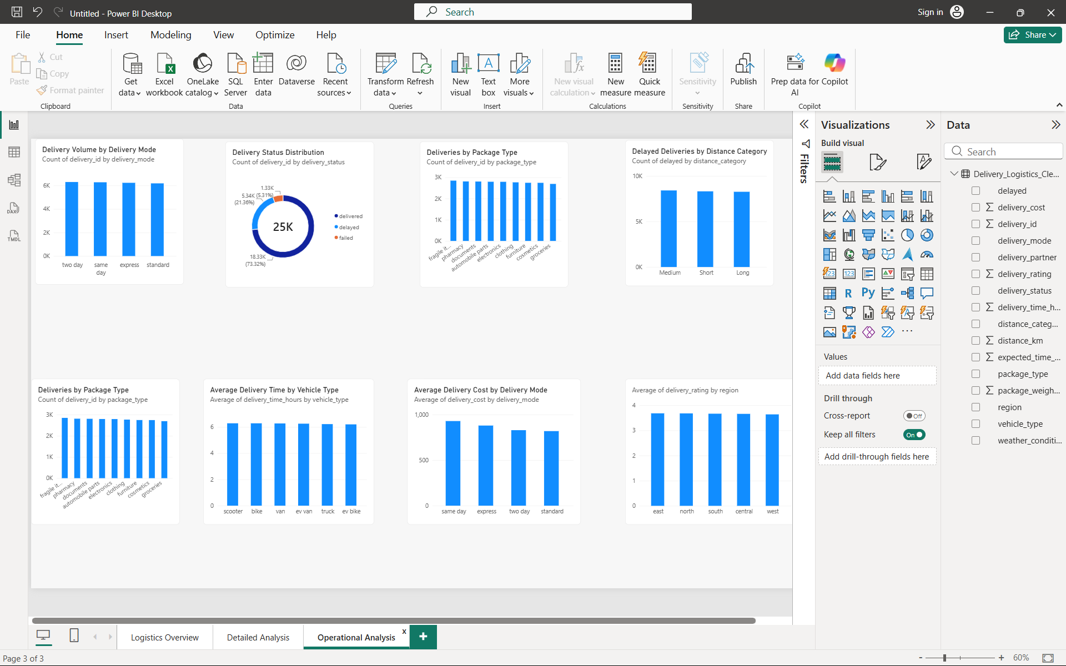
Figure 3. Operational Analysis dashboard.
Delivery Volume by Delivery Mode: The four delivery modes have similar delivery volumes, making this useful for understanding workload distribution across modes.
Delivery Status Distribution: The donut chart shows approximately 73.32% delivered, 21.36% delayed and 5.31% failed. This gives a quick view of overall delivery outcomes and highlights the proportion of records requiring attention.
Deliveries by Package Type: Package categories have broadly similar volumes in the displayed dataset. This helps establish whether workload is concentrated in particular package types.
Delayed Deliveries by Distance Category: The medium, short and long distance categories have similar delay counts in the displayed chart. This provides a useful high-level comparison of delay volume by distance group.
Average Delivery Time by Vehicle Type: Average delivery times are close across the vehicle types, remaining around the 6-hour range. The visual can be used as a baseline for future vehicle-level monitoring.
Average Delivery Cost by Delivery Mode: Average cost differs more noticeably across delivery modes than the regional cost chart. The chart provides a basis for reviewing pricing, route structure and resource usage by mode.
Average Delivery Rating by Region: Regional ratings are closely grouped around the mid-3 range. This suggests that service ratings are relatively consistent across regions in the current dataset.

9. Key Findings
- The dashboard contains approximately 25K delivery records and summarizes them through a compact set of operational KPIs.
- Overall delivery status is predominantly delivered, while delayed and failed deliveries represent smaller but operationally important groups.
- Distance has a visible positive relationship with both delivery time and delivery cost.
- Regional average delivery time, cost and rating values are relatively close, indicating no extreme regional gap in the displayed measures.
- Delivery volumes and delay counts are broadly distributed across many categories rather than being concentrated in one category.
- The delivery-mode status chart provides a useful way to identify differences in outcome mix between delivery modes.

10. Recommendations for Logistics Operations
- Use distance-aware delivery-time estimates because longer routes are associated with higher delivery time.
- Use distance and delivery-mode information when reviewing delivery costs and route planning.
- Monitor delayed and failed deliveries separately from successfully delivered shipments so that operational issues are not hidden by overall delivery volume.
- Track partner, vehicle and regional metrics periodically to detect changes that may not be visible in a single reporting period.
- Use delivery ratings alongside operational metrics to ensure that efficiency improvements do not reduce service quality.
- Refresh the dashboard regularly so managers can compare current performance with previous periods.

11. Impact of Visual Communication on Logistics Decision-Making
Data visualization reduces the effort required to interpret large logistics datasets. Instead of reviewing thousands of individual delivery records, decision-makers can quickly compare regions, delivery modes, vehicles, partners and package categories. Relationship charts can also reveal how numerical factors such as distance relate to delivery time and cost. This makes the reporting process more accessible and supports faster operational monitoring, resource planning, route review and performance discussions.

12. Conclusion
The Power BI logistics report converts delivery data into a structured visual reporting system. The three dashboard pages combine KPI cards, comparison charts, a status composition chart and scatter plots to present both high-level performance and detailed operational patterns. The resulting visual report demonstrates how clear data presentation can help logistics teams monitor performance, identify areas requiring attention and support evidence-based operational decisions.

